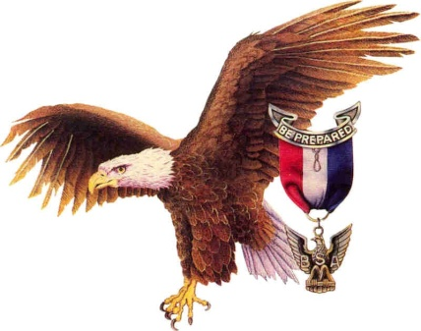
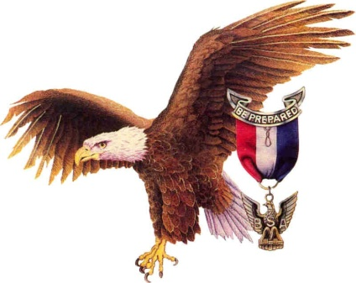

Life to Eagle
Eagle Scout Candidate
Unit Coach Check List

1. Acts as Unit Advocate for Eagle Scout Candidate.
2. Works closely with Unit Leader.
3. Works with Unit Advancement Chairperson.
4. Ensures that new Life Scouts receive Life to Eagle Packets and that current Life Scouts receive updated Eagle Scout Information, requirements, and forms.
5. Monitors progress of Life Scouts a. Merit Badges needed.
b. Leadership requirements.
c. Requests Board of Review for Life Scouts and others who are not advancing by age sixteen. Follows up every six months.
d. When necessary, writes contract for Eagle Scout Candidate detailing Troop requirements regarding Troop Leadership, Troop participation, and Scout Spirit.
6. Meet with Life Scout and Parents
a. Explains Eagle Scout process and role of parents.
b. Coach Eagle Scout candidates regarding goal setting and mapping out an action plan.
c. Schedules follow-up meetings with Eagle Scout Candidate.
7. Counsels Eagle Candidate Regarding Eagle Scout Project. a. Advises on selection of Eagle Scout Project.
b. Advises candidate on preliminary project plans and approvals.

c. Ensures the Eagle Scout candidate appears before the Unit committee for project approval.
d. Ensures that Eagle Scout candidate procures District Advancement Chairperson's signature before project execution.
e. Monitors Unit's assistance during Eagle Scout Project.
f. Critiques completed Eagle Scout Project Notebook.
g. Advises Scout to send the confidential appraisal forms to the people listed under requirement #2 on the Eagle Application, with the instructions that the completed forms are to be mailed directly to the District Advancement Chairperson or his designee 1 to 3 months before the Eagle Board of Review.
h. Assists Eagles Scout candidate in filling out Eagle Scout Rank Application and assembling accurate records for leadership, Merit Badges and rank advancement.
i. Ensures that the Eagle Scout candidate participates in a Scoutmaster Conference and Unit Technical Eagle Scout Board of Review.
j. Ensures that Eagle Scout candidate contacts the District Eagle Scout Board of Review Chairperson for final review of the Eagle Scout Application, approval of Project Notebook, and scheduling of the District Eagle Scout Board of Review.
8. Upon receipt of the Eagle Scout Rank, assists the Eagle Scout candidate and his family in planning the Eagle Scout Court of Honor.

