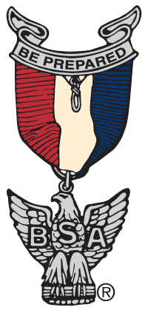

Orange County Council Advancement Committee
Group Merit Badge Day Flyer
Recommended Items to Include

- “APPROVED BY THE ORANGE COUNTY COUNCIL ADVANCEMENT COMMITTEE”
- Unit Type and Number
- District
- Location of Group Merit Badge Day, Name, Address, City, & Zip Code
- Date of Group Merit Badge Day
- Check-in Time, Ceremony Start Time, 1st Session Start Time, Lunch Time, 2nd Session Start Time, End Time
- Last Date to Register
- Registration Information
- Fee $20 Maximum & Material Fee
- Lunch Fee $5 Maximum & give description of what is included
- List of Merit Badges – include any prerequisites
- Name of Point of Contact or Coordinator, E-mail
- Registrar, E-mail
General Instructions
- Each Scout must bring: (a) completed blue card signed by their Unit Leader for each Merit Badge. (b) Appropriate Merit Badge Pamphlets (c) Pen and Paper, and (d) All other material required for specific Merit Badge.
- Scouts must bring appropriate proof of completion of all prerequisites and be prepared to discuss, report, demonstrate, and be tested on all prerequisites.
- Each Scout must complete all prerequisites before class. Items that cannot be brought to class because of size or logistics must have proof in the form of photos or completions signed by Unit Leader. All written work including worksheets and drawings must be brought to class. To be unprepared is not fair to those who have prepared and to the Counselors reviewing the subjects. Remember Merit Badges are EARNED, not given out.
- Each Scout should wear official BSA Scout Uniform (or Venture Crew’s selected uniform) and appropriate footwear (no flip-flops).
- Registration and class assignments are on a first come, first served basis. No refunds will be given for any reason. Scouts who cannot afford the registration fee should contact the Registrar about scholarships available.
- Parents and Scout leaders are welcome. Each Troop should be accompanied\supervised by an appropriate number of adults.
- An E-mail confirmation will be sent to each Scout and must be presented for admittance to the Group Merit Badge Day.
- Permission Form. Note: use only the National Council Permission Form from:
https://filestore.scouting.org/filestore/pdf/19-673.pdf

