


Advancement Committee
Merit Badge Blue Card Replacement Policy

- The Scout must get a new Blue Card, BSA No. 34124.
- The Scout must secure their Unit Leader’s signature (blue arrow1) with the original date in which the Merit Badge Blue Card was first obtained. This date must be on or precede the date of starting the Merit Badge for the “Application For Merit Badge” portion of the Blue Card.
- The Scout must completely fill out the Blue Card per each red arrow indicated on the 2nd page of this policy.
- The Scout must contact the Merit Badge Counselor who signed their lost Blue Card and secure the Counselor’s mailing address. The Scout must also get all the other information in order to be able to fill in each red arrow on the 2nd page of this policy, which includes the Merit Badge Counselor’s contact information.
- The Scout must send their replacement Blue Card to the Merit Badge Counselor along with a self-addressed stamped envelope.
- The Scout must indicate in the “Remarks” area of the Merit Badge Counselor’s portion of the Blue Card: “Replacement of Lost Blue Card”
- After receiving the replacement Blue Card back from the Merit Badge Counselor, the Scout must get their unit leader’s signature on Part 2 of the Blue Card.
- The Scout must turn in Part 1 of the Blue Card to their unit leader for record posting.

Note 1: To be filled in by: Scout ( ), Unit Leader ( ), Merit Badge Counselor ( ) see 2nd page

Page 1 of 2

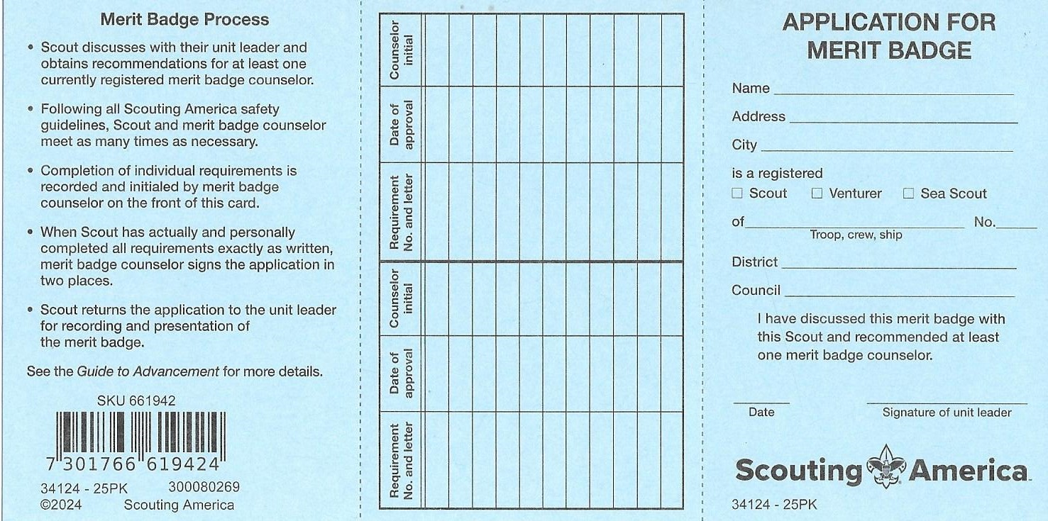

Front Side – Part 3 Front Side – Part 2 Front Side Part - 1 Filled in by: Scout ( ) Unit Leader ( ) Merit Badge Counselor ( )
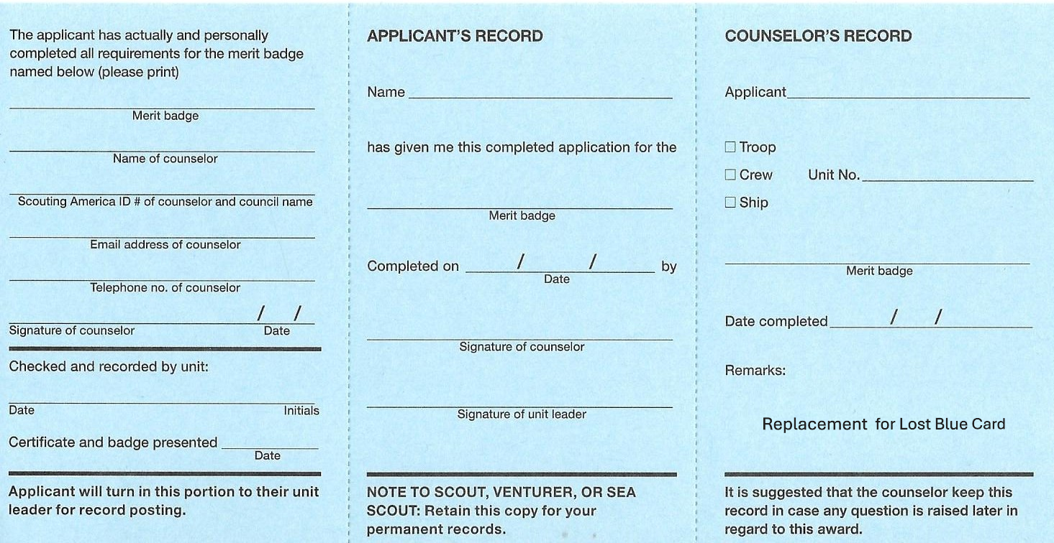

Back Side – Part 1 Back Side – Part 2 Back Side Part – 3

Revision: May 12, 2025 Page 2 of 2

